HANOI UNIVERSITY OF SCIENCE AND TECHNOLOGY

SCHOOL OF INFORMATION AND COMMUNICATION TECHNOLOGY
──────── * ───────

THESIS
SUBMITTED FOR PARTIAL FULFILLMENT OF
THE REQUIREMENTS FOR THE DEGREE OF
ENGINEER
IN
INFORMATION TECHNOLOGY

Mobile Online Game
“Tiến lên miền Nam”

Author: Nguyen Hoang Son
Class ICT-55
Supervisor: [Dr.] Nguyen Thanh Hung

HANOI May-2014
REQUIREMENTS FOR THE THESIS
1. Student information
Student name: Nguyen Hoang Son
Tel: 01654352494 Email: sonnguyenhoang2309@gmail.com
Class: ICT55 Program: Undergraduate
This thesis is performed at:
From DD/MMM/2015 to DD/MMM/2015

2. Goal of the thesis
To build an online game system and system management tool for Vietnamese card game “Tiến lên miền Nam”.

3. Main tasks
- Build a client-server system based on socket connection.
- Develop game logic on server.
- Enrich game content with multiple extra features.
- Build a management tool on web.

4. Declaration of student:
I – Nguyen Hoang Son - hereby warrant that the Work and Presentation in this thesis are performed by myself under the supervision of [Dr.] Nguyen Thanh Hung.
All results presented in this thesis are truthful and are not copied from any other work.

Hanoi, DD MMM YYYY
Author

Nguyen Hoang Son

5. Attestation of the supervisor on the fulfillment of the requirements of the thesis:
May be hand written by the supervisor

Hanoi, DD MMM YYYY
Supervisor

[Dr.] Nguyen Thanh Hung

TÓM TẮT NỘI DUNG ĐỒ ÁN TỐT NGHIỆP

Nội dung đồ án tốt nghiệp bao gồm:
Chương 1 – Phần mở đầu: Giới thiệu đề tài, xác định mục tiêu, nội dung và phạm vi thực hiện của đồ án tốt nghiệp.

Chương 2 – Phân tích yêu cầu hệ thống: Phân tích những yêu cầu của hệ thống, biểu diễn các chức năng của hệ thống bằng các biểu đồ Usecase và đưa ra giải pháp công nghệ.

Chương 3 – Thiết kế hệ thống: Thiết kế chương trình chạy trên server cho game bài “Tiến lên miền Nam”, mô hình kết nối giữa các thành phần, thiết kế cơ sở dữ liệu.

Chương 4 – Cài đặt và thử nghiệm: Mô tả chi tiết phần cài đặt và kết quả đạt được của chương trình.

Kết luận: Đánh giá về đồ án, kết quả đạt được và các mặt còn hạn chế , từ đó đưa ra định hướng phát triển hệ thống trong tương lai.
ABSTRACT OF THESIS

Content of graduation project includes:

Chapter 1 – Introduction: Introduction about purpose of the thesis and the scope of work.

Chapter 2 – System analysis: Detail analysis of system requirement, Use Case diagram of system function, proposed solution and introduction of technologies used on the project.

Chapter 3 – System design: Design of server program for the game “Tiến lên miền Nam”, interactive model of system components and database design.

Chapter 4 – System implementation and testing: The result of implementation and testing.

Conclusion: Assessment of project achievements and limitations, suggestion of possible improvement for the system in the future.

Table of Contents
LIST OF FIGURES 6
LIST OF TABLES 7
ACRONYMS 8
CHAPTER 1: INTRODUCTION 9
1. Motivation 9
2. Card game “Tiến lên miền Nam” 9
3. Scope of work 11
CHAPTER 2: SYSTEM ANALYSIS 12
1. System requirement 12
2. Requirement analysis 12
2.1. Functional diagram 12
2.2. Use case diagram 12
3. Proposed Solution 13
3.1. Netty 13
3.2. Quartz Scheduler 13
3.3. Memcached 14
3.4. Struts 14
CHAPTER 3: SYSTEM DESIGN 15
1. System architecture 15
2. Database design 15
2.1. Entity Relationship Diagram 15
2.2. Table Design 15
CHAPTER 4: SYSTEM IMPLEMENTATION AND TESTING 23
1. Connection handling 23
1.1. Data package format 23
1.2. Connection handling 23
1.3. Data package processing 26
2. Program function 29
2.1. Log in 29
2.2. Event 29
2.3. Roulette 30
2.4. Giftcode 30
2.5. Chatbox 31

LIST OF FIGURES

Figure 1. Functional Diagram 13
Figure 2. Support Feature Use case diagram 14
Figure 3. Game Use case diagram 15
Figure 4. User management Use case diagram 16
Figure 5. Event management Use case diagram 16
Figure 6. News/Announcement management Use case diagram 16
Figure 7. Other management Use case diagram 17
Figure 8. How an event flows in a pipeline 31
Figure 9. Package handling classes 33

LIST OF TABLES

Table 1. USER table 17
Table 2. FRIEND table 18
Table 3. CHAT_MESSAGE table 18
Table 4. GIFTCODE table 18
Table 5. LEVEL table 19
Table 6. TABLE table 19
Table 7. USER_TABLE table 19
Table 8. ROULETTE_MODE table 20
Table 9. ROULETTE_PRIZE 20
Table 10. LOG_ROULETTE 20
Table 11. EVENT table 21
Table 12. EVENT_ITEM table 21
Table 13. EVENT_GIFT table 22
Table 14. INVENTORY table 22
Table 15. LOG_GIFT table 23
Table 16. NEWS table 23
Table 17. ANNOUNCEMENT table 23
Table 18. ADMIN table 24
Table 19. CHATBOX table 24

ACRONYMS

NIO: Non-blocking in/out

CHAPTER 1: INTRODUCTION

Motivation
Up until now, out of over 90 million people in population, there are 30.9 million Vietnamese people who are able to interact with the internet. Within this group, people between the age of 15 and 24 take up to 95%. The high percentage of young people using internet means that the potential for online service and entertainment channel to keep growing up and make profit is still up in the air. Apparently, online game and especially mobile game play a huge role in that growth.

According to a report of Gamek.vn, the revenue from online mobile game in 2014 has gone up 37.3% compared to 2013 and it is estimated to continue to grow and reach the peak of 50% in 2016. This statistic again shows a lot of possibility for any company to make profit from online mobile game market.

Among the genre of game on the market, card battle game takes the largest portion of the chart with 27.61%. This number indicates that Vietnamese people have a strong interest in different kind of card game, either traditional or Western modern style. Therefore, taking these facts into account, the thesis follows the idea of building an online mobile game system which centers around a traditional card battle game titled as “Tiến lên miền Nam”.

Card game “Tiến lên miền Nam”
“Tiến lên miền Nam” , also known as Vietnamese cards, Thirteen or American Killer is a Vietnamese shedding-style game which means the object of the game is to discard all cards from player’s hand as quickly as possible.

Cards
A standard deck of fifty-two playing cards is used. The ranking of the cards from highest to lowest is: 2 A K Q J 10 9 8 7 6 5 4 3. The cards are also ranked based on their suits. The ranking from highest to lowest is: Hearts♥ Diamonds♦ Clubs♣ Spades♠. Therefore, the 2♥ is the highest single card in the game and the 3♠ is the lowest card.

Combinations
- Single (Rác): A single played card.
- Pair (Đôi): A combination of exactly 2 cards of same number.
- Triple (Ba lá): A combination of exactly 3 cards of same number.
- Straight (Sảnh): A combination of at least 3 cards that are in numerical sequence. 2 cannot be included in a straight.
- Pair sequences (Đôi thông): A combination of at least 3 pairs that are in numerical sequence and doesn’t have to be the same color.
- Four-of-a-kind (Tứ quý): A combination of all four cards of equal rank.

Defeat (Chặt)
- Group of cards has the strongest card beats the other group of the same combination.
- 3-pair sequence beats a single 2.
- Four-of-a-kind beats a single 2, 3-pair sequence and smaller four-of-a-kind.
- 4-pair sequence beats a single 2, pair of 2, 3-pair sequence, four-of-a-kind and smaller 4-pair sequence.

Instant win (Thắng trắng)
A player scores an instant win when group of cards in his hand satisfy one of the following condition:
- Have four 2s.
- 5-pair sequence.
- 6 pairs.
- Dragon’s Head (Sảnh rồng) 3-A.

Win/lose money
Money is calculated at the end of the match based on the number of cards that loser has in his hand. Strong card or special combination is exchanged for value differently since the player cannot release its strength during the game.
- 2♣ 2♠ has the value of 2 cards.
- 2♥ 2♦ has the value of 5 cards.
- 3-pair sequence has the value of 5 cards.
- Four-of-a-kind has the value of 7 cards.
- 4-pair sequence has the value of 13 cards.

Play
- The person with the 3♠ or the lowest card commences the game.
- The direction of play is counter-clockwise.
- In a turn, a player can decide to play or not. A player who passes cannot play anymore until the remaining players pass.
- When a player plays a combination and everyone passes, he or she has control and can play any legal combination.
- The first player to shed all thirteen cards is declared the winner.
- The winner of previous round starts the next round instead of player holding 3♠ card.

Scope of work
The game built in the thesis is an online game product which is capable of receiving revenue and making profit by distributing game client to multiple publishers. The method of charging user is planned to be in-app purchase by card but within the scope of the thesis, payment function is not included. Geographically, the game server can only serve internet connection in Vietnam at best quality since the system only has one working server.

The project of this thesis is built by a group of 3 developers. As the other 2 developers are working on to develop client on mobile, I take the responsibility of constructing a server program for the game and a backend web to manage the system.

CHAPTER 2: SYSTEM ANALYSIS

System requirement
Game server must fulfill the following requirement:
- Serving approximately1000 concurrent users with minimum delay.
- Response to client in real time.
- Handle client’s disconnection and reconnection.
- Prevent any kind of cheating and hacking.
- Provide the following function:
  - User’s logging in and registering
  - Table creating, finding, joining and canceling
  - Game playing
  - Event participation
  - Roulette playing
  - Chatting
  - Friend making and inviting
  - Gift code

Back end web must provide admin the capability to:
- Manage user.
- Manage news, announcement.
- Manage event.
- Manage chat box.
- Look up game’s log.
- Manage gift code.

Requirement analysis

Functional diagram
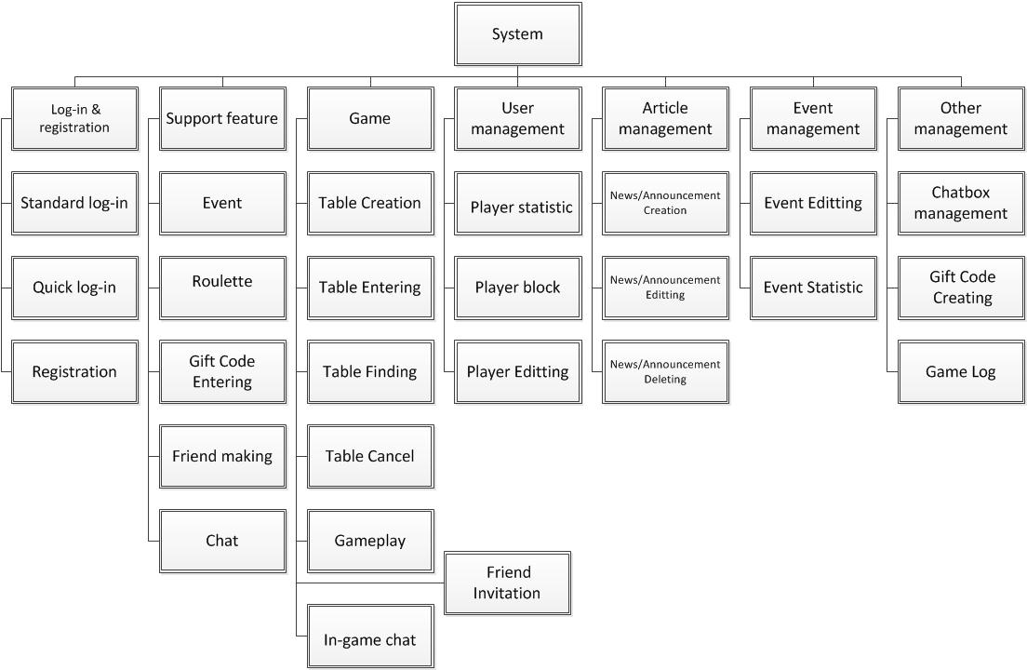
Figure 1. Functional Diagram

Use case diagram

Support Feature
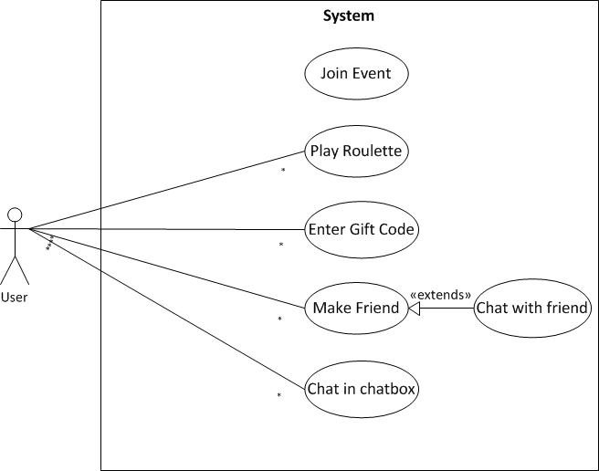
Figure 2. Support Feature Use case diagram

Game
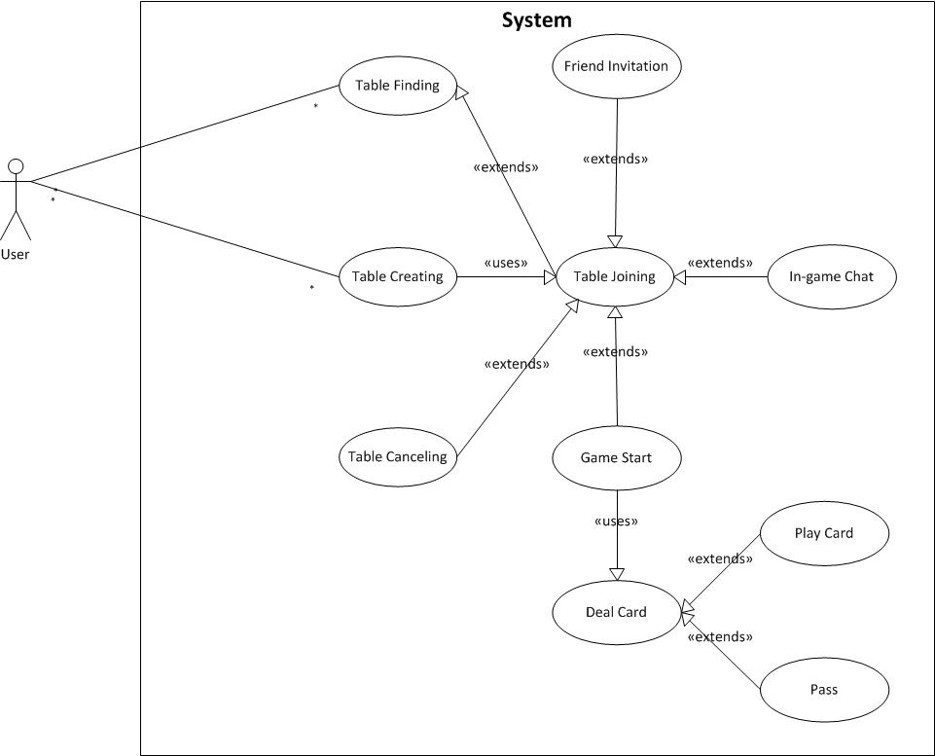
Figure 3. Game Use case diagram

User management
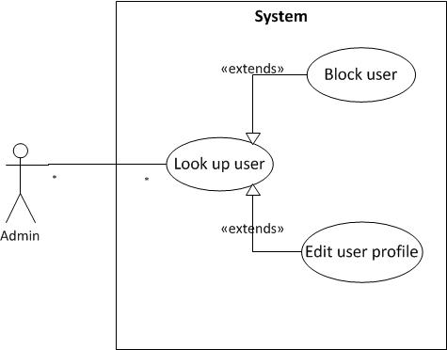
Figure 4. User management Use case diagram

Event management
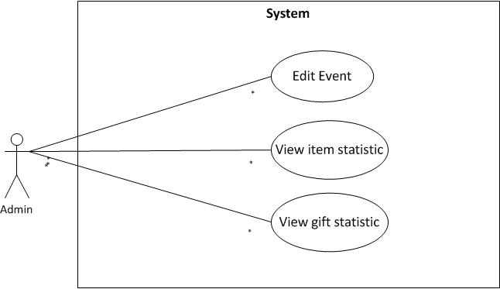
Figure 5. Event management Use case diagram

News/ Announcement management
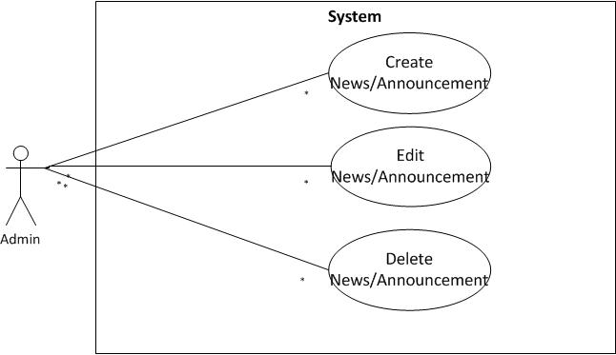
Figure 6. News/Announcement management Use case diagram

Other management
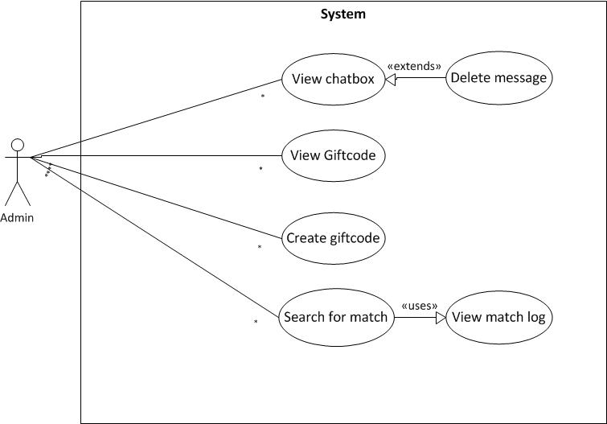
Figure 7. Other management Use case diagram

Proposed Solution

Netty
Because mobile client connects to game server through a non-blocking network connection model, a network application framework is recommended for the server to be quickly and easily to develop. In that sense, Netty has been chosen for rapid development and its popularity among the community.
Netty is a non-blocking I/O (NIO) client-server framework for the development of Java network applications such as protocol servers and clients. The asynchronous event-driven network application framework and tool are used to simplify network programming such as TCP and UDP socket servers. Netty includes an implementation of the reactor pattern of programming. Originally developed by JBoss, Netty is now developed and maintained by the Netty Project Community.

Besides being an asynchronous network application framework, Netty also includes built-in HTTP protocol support, including the ability to run inside a servlet container, support for WebSockets, integration with Google Protocol Buffers, SSL/TLS support, support for SPDY protocol for message compression.

Quartz Scheduler
As the game runs in real time along with the client, server program frequently have to perform task after a period of time such as ending a turn or end a match. This raises the need of a task scheduler library support and Quartz Scheduler stands out as the best one in this particular job.

Quartz is a richly featured, open source job scheduling library that can be integrated within virtually any Java application – from the smallest stand-alone application to the largest e-commerce system. Quartz can be used to create simple or complex schedules for executing tens, hundreds, or even tens-of –thousands of jobs; jobs whose tasks are defined as standard Java components that may execute virtually everything we may program them to do. The Quartz Scheduler includes many enterprises-class features, such as support for JTA transactions and clustering.

Memcached
In a real time online application, response time of server is a very important factor that decides if the experience of user is smooth or laggy. One of the reasons that usually increase the response time to a client request is the delay from the interaction of server to database for frequently used data. To compensate for this setback, a memcached server is set up to run along with the game server to cache all the data that is common to all users and those one that rarely change.

Memcached is a general-purposed distributed memory caching system. It is often used to speed up dynamic database-driven application by caching data and objects in RAM to reduce the number of times an external data source must be read. Memcached’s APIs provide a very large hash table distributed across multiple machine. When the table is full, subsequent inserts cause old data to be purged in least recently used order (LRU). Applications using typically layer requests and addition into RAM before falling back on a slower backing store such as database.

The size of this hash table is very large. It is limited by available memory across a large number of servers in data center. Memcached can be equally valuable for situations where either the number of requests for content is high or the cost for generating a particular piece of content is high.

Struts
To simplify and rapidly develop the back end web tool, a Java web framework called Struts is chosen as the backbone for management system. Apache Struts is a free, open-source, MVC framework for creating elegant, modern Java web applications. It favors convention over configuration, is extensible using a plugin architecture, and ships with plugins to support REST, AJAX and JSON.

CHAPTER 3: SYSTEM DESIGN

System architecture
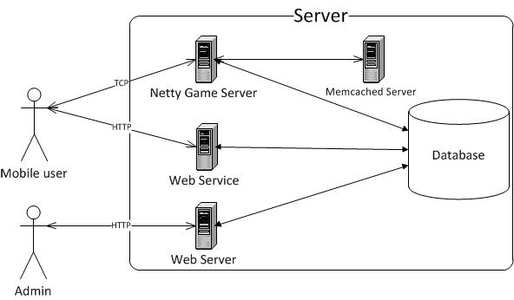

Figure 8. System Architecture

The system has one physical server. It is installed with multiple server software to serve different purposes.

Netty Game Server is built on Netty framework taking the duty of handling TCP connection from client, processing message and running game logic. Game server is composed of components:
- Data Access Component: Interact with the database, retrieving data and modifying data.
- Connection Handling Component: Deal with connection event triggered by network like opening connection, disconnecting…
- Package Process Component: Unpack the package upon receiving and extract data according to a predefined format.
- Logical Component: Perform business logic of the server.
- Logging Component: Write essential information to log file for future back trace.
Web Service is an addition to support the function of game system. It provides an interface to send and receive chat message and is the avatar provider.

Memcached Server runs along with game server to provide a memory space to store frequently requested data. It eases the operation of interacting with database which usually causes a long time of delay.

Web Server runs a backend web-interface management system. The web is mainly responsible for manipulating data and show statistic from database.

Database design

Entity Relationship Diagram
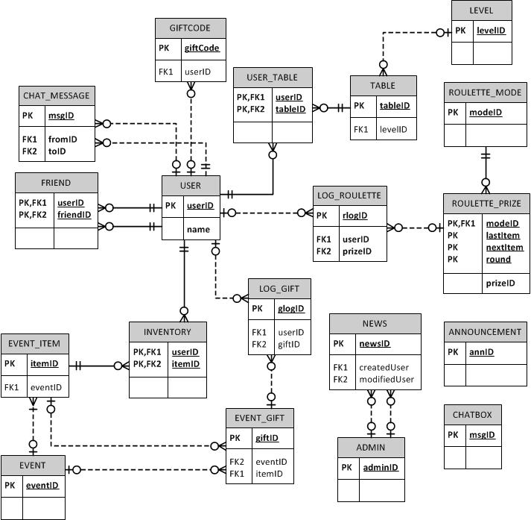
Figure 9. Entity Relationship Diagram

Table Design

USER
Field | Data type | Key | Description
userID | Int | Primary Key
Name | Varchar | Unique Key | User’s login name
Password | Varchar |  | User’s password
phoneNumber | Varchar
Gold | Int |  | User’s in-game money
isOnline | Bit |  | User’s online state
avatarPath | Varchar |  | User’s avatar path
lastLogin | Datetime |  | The last login time
Email | Varchar |  | User’s email
isActive | Bit |  | User’s state
Sex | Bit |  | Female:0, Male: 1
mobileVersion | Varchar |  | Info of device ID, OS version
registerDate | Datetime |  | User’s registering time
citizenID | Varchar |  | User’s id card number
isLock | Bit |  | User’s lock state triggered by admin
Table 1. USER table

FRIEND
Field | Data Type | Key | Description
userID | Int | PRIMARY KEY  FOREIGN KEY | Link to user table
friendID | Int | PRIMARY KEY  FOREIGN KEY | Link to user table
connectedDate | Datetime |  | Date&time 2 users make friend
Table 2. FRIEND table

CHAT_MESSAGE
Field | Data Type | Key | Description
msgID | Int | PRIMARY KEY
fromID | Int | FOREIGN KEY | Message sender
toID | Int | FOREIGN KEY | Message receiver
Title | Int |  | Message title
content | Varchar |  | Content of message
dateSent |  |  | Sending message time
Table 3. CHAT_MESSAGE table

GIFTCODE
Field | Data Type | Key | Description
giftCode | Varchar | PRIMARY KEY | Gift code used by user
userId | Int | FOREIGN KEY | User that use gift code
createdDate | Datetime
usedDate | Datetime
bonusMoney | Int |  | Money user receive by entering gift code
Table 4. GIFTCODE table

LEVEL
Field | Data Type | Key | Description
levelID | Int | PRIMARY KEY
minCash | Int |  | Minimum money user need to have to play
cashList | Varchar |  | List of table cash
numTable | Int |  | Number of table in the level
Table 5. LEVEL table

TABLE
Field | Data Type | Key | Description
tableID | Int | PRIMARY KEY
createdDate | Datetime |  | Date&time the table is created
ownerID | Int | FOREIGN KEY | User who creates the table
levelID | Int | FOREIGN KEY | Level of table
Table 6. TABLE table

USER_TABLE
Field | Data Type | Key | Description
tableID | Int | PRIMARY KEY  FOREIGN KEY | Link to TABLE
userID | Int | PRIMARY KEY  FOREIGN KEY | User who join the table
joinDate | Datetime
Table 7. USER_TABLE table

ROULETTE_MODE
Field | Data Type | Key | Description
modeID | Int | PRIMARY KEY
Value | Int |  | Amount of money user pay to play roulette
Table 8. ROULETTE_MODE table

ROULETTE_PRIZE
Field | Data Type | Key | Description
modeID | Int | PRIMARY KEY  FOREIGN KEY | Link to ROULETTE_PRIZE
lastItem | Varchar | PRIMARY KEY | Item that comes in last round of playing roulette
nextItem | Varchar | PRIMARY KEY | Item that comes in current round of playing roulette
round | Int | PRIMARY KEY | Round of roulette
prizeID | Int | UNIQUE KEY | For referring to another table
Rate | Float |  | Rate of getting the prize in percentage
multiplier | Float |  | Prize = multiplier x value
Table 9. ROULETTE_PRIZE

LOG_ROULETTE
Field | Data Type | Key | Description
rlogID | Int | PRIMARY KEY
userID | Int | FOREIGN KEY | Link to USER
prizeID | Int | FOREIGN KEY | Link to ROULETTE_PRIZE
logDate | Datetime
Table 10. LOG_ROULETTE

EVENT
Field | Data Type | Key | Description
eventID | Int | PRIMARY KEY
name | Varchar |  | Event’s name
content | Varchar |  | Event’s introduction
description | Varchar |  | Rule of play
components | Varchar |  | Items of event
type | Int |  | Type of event
isActive | Bit
Table 11. EVENT table

EVENT_ITEM
Field | Data Type | Key | Description
itemID | Int | PRIMARY KEY
eventID | Int | FOREIGN KEY | Link to EVENT
name | Varchar |  | Item’s name
description | Varchar |  | Item’s description
Rate | Float |  | Rate of dropping item in percentage
type | Int |  | Type of item
quantity | Int |  | Amount of item could be dropped during the event
isActive | Bit
Fee | Int |  | Money that user have to pay to own item
Limit | Int |  | Max number of items user may own
Table 12. EVENT_ITEM table

EVENT_GIFT
Field | Data Type | Key | Description
giftID | Int | PRIMARY KEY  FOREIGN KEY | Link to ROULETTE_PRIZE
eventID | Int | FOREIGN KEY | Link to EVENT
itemID | Int | FOREIGN KEY | Link to EVENT_ITEM
name | Varchar |  | Gift’s name
description | Varchar |  | Gift’s description
Rate | Float |  | Rate of achieving the gift in percentage
value | Int |  | Money prize of the gift
quantity | Int |  | Amount of gift in the event
isLimit | Bit |  | Whether user can achieve the gift more than 1
Table 13. EVENT_GIFT table

INVENTORY
Field | Data Type | Key | Description
userID | Int | PRIMARY KEY  FOREIGN KEY | Link to USER
itemID | Int | PRIMARY KEY  FOREIGN KEY | Link to EVENT_ITEM
quantity | Int |  | Amount of item user owns
Table 14. INVENTORY table

LOG_GIFT
Field | Data Type | Key | Description
glogID | Int | PRIMARY KEY
userID | Int | FOREIGN KEY | Link to USER
giftID | Int | FOREIGN KEY | Link to EVENT_GIFT
date | Datetime |  | Gift achieving time
fromValue | Int |  | Money before achieving gift
toValue | Int |  | Money after achieving gift
Table 15. LOG_GIFT table

NEWS
Field | Data Type | Key | Description
newsID | Int | PRIMARY KEY
Title | Varchar |  | Headline
content | Varchar |  | Content of the news
createdDate | Datetime
modifiedDate | Datetime
createdUser | Int | FOREIGN KEY | Link to ADMIN
modifiedUser | Int | FOREIGN KEY | Link to ADMIN
Table 16. NEWS table

ANNOUNCEMENT
Field | Data Type | Key | Description
annID | Int | PRIMARY KEY
Title | Varchar |  | Announcement’s title
content | Varchar |  | Announcement’s content
createdDate | Datetime
fromDate | Datetime |  | Announcement is active from this date
toDate | Datetime |  | Announcement is active to this date
Table 17. ANNOUNCEMENT table

ADMIN
Field | Data Type | Key | Description
adminID | Int | PRIMARY KEY
name | Varchar | UNIQUE KEY | Admin’s login name
password | Varchar |  | Admin’s password
Table 18. ADMIN table

CHATBOX
Field | Data Type | Key | Description
msgID | Int | PRIMARY KEY
username | Varchar |  | User who sends message
content | Varchar |  | Message’s content
createdDate | Datetime
Table 19. CHATBOX table

CHAPTER 4: SYSTEM IMPLEMENTATION AND TESTING

Connection handling

Data package format
The application uses JSON as data format to exchange data between client and server due to its lightweight and well-defined structure. The data package format has the following form for both request and response:
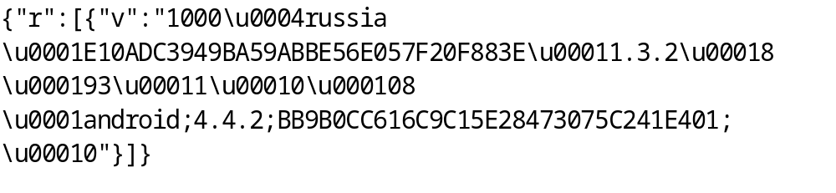In the above code, the key value “r” specifies the content of request/response package. A package may contain one or more request/response messages which are sent from either client or server, so the value part of “r” is usually an array of message object. Each message begins with the key value “v” which specifies the data trunk with every element split up by a separator. As in the example, the first element always represents message code that defines what kind of request is sent or which request the server responses to. ’\u0004’ is separator that usually stands between message code and other data. The remaining section is the combination of multiple parameters separated by ‘\u0001’ character (also known as element separator). In case of a parameter which contains multiple arrays, it is wrapped between a pair of array separators “\u0003” to mark a section of array data for JSON parser. Each individual array in the set also gets its own area by having “\u0002” character as the boundary.

Connection handling
Netty provides developers a strong support on handling network connection with a good structural class design and a thoroughly implemented mechanism. There are several classes in Netty package that application can extend from to build a network communicating program; however, to develop a server that works in NIO model, NioServerSocketChannelFactory is the class to begin with.
NioServerSocketChannelFactory
NioServerSocketChannelFactory is a ServerSocketChannelFactory which creates a server-side NIO-based ServerSocketChannel. It utilizes the non-blocking I/O mode which was introduced with NIO to server many number of concurrent connections efficiently.
There are two types of threads in a NioServerSocketChannelFactory:
- Boss thread: Each bound ServerSocketChannel has its own boss thread. For example, if two server ports such as 80 and 443 are opened, two boss threads will be created. A boss thread accepts incoming connections until the port is unbound. Once a connection is accepted successfully, the boss thread passes the accepted Channel to one of the worker threads that the NioServerSocketChannelFactory manages.
- Worker thread: One NioServerSocketChannelFactory can have one or more worker threads. A worker thread performs non-blocking read and write for one or more Channels in a non-blocking mode.

ChannelPipeline
After the connection channel is formed and passed to worker thread to control reading and writing, there is a need of class that actually handles channel event and performs business logic of the application. ChannelPipeline is the interface for those classes that takes the first touch when a channel event is triggered to handle the task.
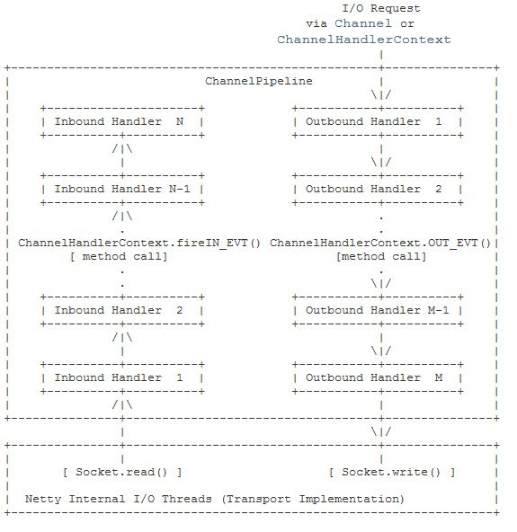
Figure 10. How an event flows in a pipeline
ChannelPipeline is a list of ChannelHandlers which handles or intercepts ChannelEvents of a Channel. ChannelPipeline implements an advanced form of the InterceptingFilter pattern to give developers full control over how an event is handled and how the ChannelHandlers in pipeline interact with each other.

A ChannelEvent can be handled by either a ChannelUpstreamHandler or a ChannelDownStreamHanlder and be forwarded to the closest handler by calling ChannelHandlerContext.sendUpstream(ChannelEvent) or ChannelHandlerContext.sendDownsteram(ChannelEvent). An upstream event is handled by the upstream handlers in the bottom-up direction. An upstream handler usually handles the inbound data generated by the I/O thread on the bottom of the diagram. The inbound data is often read from a remote peer via the actual input operation. If an upstream event goes beyond the top upstream handler, it is discarded silently.

SimpleChannelUpstreamHandler
SimpleChannelUpstreamHandler is the implementation of ChannelUpstreamHanlder which provides an individual handler method for each event type. This handler down-casts the received upstream event into more meaningful sub-type event and calls an appropriate handler method with the down-cast event.
This class possesses several important methods which can be overridden to handle triggered event from channel. These methods are:
- channelOpen: Invoked when a Channel is open, but not bound or connected.
- channelBound: Invoked when a Channel is open and bound to a local address, but not connected.
- channelConnected: Invoked when a Channel is open, bound to a local address and connected to a remote address. This method is the place where user’s session is created and initialized.
- channelDisconnected: Invoked when a Channel was disconnected from its remote peer. This method is the place where user’s session is cleaned up and closed.
- channelUnbounded: Invoked when a Channel was unbound from the current local address.
- channelClosed: Invoked when a Channel was closed and its related resources were released.
- messageReceived: Invoked when a message object was received from a peer. This is the entrance to all the business processes in the program. Received message is extracted for valuable data which is then passed to an appropriate JSON parser by a package distributing mechanism.

ISession/SocketSession
ISession interface and SocketSession class are not parts of Netty framework but they act as a representative for a user’s connection in the system. A session is created when server triggers channelConnected event and it is destroyed on channelDisconnected event handler. A session object is stored in a session map which is associated with a SessionManager object with user’s id being the key. Every interaction of users in the server is represented by their session.

Data package processing
When Netty server receives the data package, a channel event is triggered and it comes down to method messsageReceived of SimpleChannelUpstreamHandler class to further process this package. The class takes primary responsibility for controlling package handling process is an implementation of IWorkflow interface, SimpleWorkflow class. Method process of this class is called on messageReceived to perform backbone logic of package extracting and decoding by calling other methods from associated classes. Before going into detail of how the data package is handled, there is a brief introduction of classes/interfaces that involve in the process.

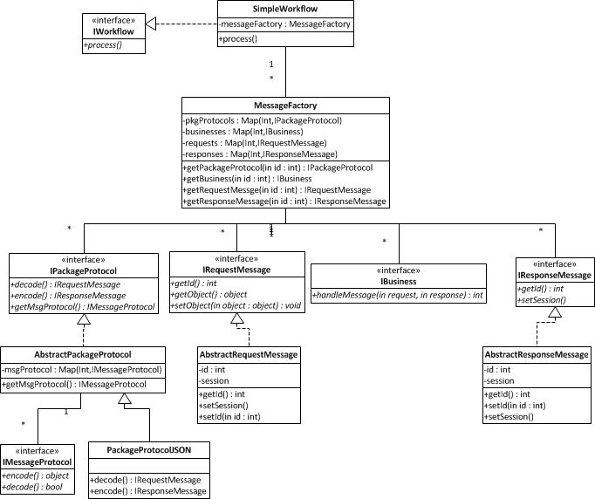
Figure 11. Package handling classes

- SimpleWorkflow is an essential class of game server program because it contains methods which run different initializing procedures such as loading server config, list of game messages, setting up database connection and loading startup data from database. It has the access to MessageFactory object which holds many important links to core objects of the program. Process method of the class also plays a key role in the process of handling the data package.

- MessageFactory has the association with many important classes that can be crucial to perform program business logic. MessageFactory object possesses four hashtables of business objects, request objects, response objects and package protocols. These four hashtables holds all necessary resources to process any type of extracted message from data package. At the start of the program, MessageFactory reads from an xml file message-config.xml the list of all possible messages in the program. With each message entry, a business object, a request message object and a response object are initialized accordingly and thereafter they are put into respectable hashtable.

- IPackageProtocol/PackageProtocolJSON extends from AbstractPackageProtocol class which implements IPackageProtocol interface performs two main functions that are encoding and decoding the data package.

- IRequestMessage is the interface for all request message objects in the program. Some of the message objects implement this interface are LoginRequest, LogOutRequest, RegisterRequest …

- IResponseMessage is the interface for all response message objects in the program. Some of the message objects implement this interface are LoginResponse, LogOutResponse, RegisterResponse …

- IBusiness is the interface for all business objects in the program. Some of the business objects implement this interface are LoginBusiness, LogOutBusiness, RegisterBusiness … Every business class has handleMessage method to run logic code to perform a business task.

- IMessageProtocol is the interface for all message parsing objects in the program. In this program, every JSON parser object implements this object to function both as a decoder and an encoder for a specific kind of message.

Firstly, data package runs into PackageProtocolJSON’s decode() method where the message array of “r” is taken out by JSON parser. The array of messages is looped over so that each message is treated differently. Message code is the only field to be extracted out of the message in this method because the remaining data is passed to an object of message protocol for further decoding. Message code is a very important factor of the message since it determines message’s uniqueness and it is the key for server program to initialize all related object (request, response, business).

Secondly, the main data section (after message code) will be an input for decode method of a message protocol object which is initialized by the message code. Each message protocol class parses the data differently according to the meaning of each field before returning a complete response message object. After that request message is passed along with user session object to appropriate business object retrieved from business hashtable of MessageFactory. Business logic code runs inside handleMessage method to perform program’s function and at the end of that, a response message is constructed and written into the channel.

Program function

Log in
There are two kind of logging in: standard log-in and quick log-in.
Standard log-in is the traditional one when user enters username and password and sends to server for authentication. A message with code 1000 specifies Log In message is sent to the server including username, password and device info. LoginBusiness’s handleMessage performs a database lookup to authenticate user’s information and write a response in return to client.

Quick log-in also known as Guest log-in is the kind of login that the user doesn’t need to have a username in the system but he’s still able to log in to the game. This log-in method bases on the uniqueness of mobile device id to identify the user. GuestLoginBusiness will register a new device id to the system if it is the first time log in from the device and user will be logged in with username ‘guest***’ where *** is a generated and unique number to distinguish between guests.

Event
Event is a supporting feature of the game which provides user with opportunity to achieve more money by playing simple, pure-luck game. A list of active event is cached into memcached server since it is a rarely changed data and frequently requested by the client. However, if new event goes active, the event refresh interval is 30 minutes for the change to take effect. The event comes with two formats: flipping card and collecting items.
On flipping card event, FlippingCard message is sent to server with event’s id packaged inside. FlippingCardBusiness then loads an array of card items and gifts in memcached by querying with the event’s id and runs an algorithm to random a number. The gift that user can get will depend on the random number comparing to rate of success of each gift. The higher the reward gets, the smaller the rate is. After that money reward is added up into user’s account and a record of log is also written to the database.

On collecting items event, user needs to play “Tiến lên miền Nam” game to pick up event’s item and store it in the inventory. Usually, an event will require user to collect different items and with an exact amount of each item to form a complete event’s item. This final event’s item is valuable to be exchanged for money gift. When user wants to make complete item from its component, a JoinEventItem message with event’s id inside is sent to server. Business object retrieves user’s inventory from database and starts to check if user qualifies to form new item. This item is then saved into user’s inventory. Upon exchanging item for money gift, the logic is the same as on flipping card event.

Roulette
Each time user plays roulette, he sent to server StartRoulette message with amount of fee inside. The data of previous roulette round that user has played is taken out from memcached so that server can calculate the outcome of the next play round. The result of roulette depends on item of previous round, item of this round and how much money user bets to play. The list of possible items to come out is loaded into an array and one of them is chosen as the next item if a generated random number falls into their rate of out. Matching with the set of items that come out from every play round is a reward multiplier which will increase user’s money bet by multiplier times. Finally, the result is logged into memcached and database and user’s account balance is added with reward money.

Giftcode
User enters giftcode by sending CheckGiftcode message with the code packaged inside. CheckGiftcodeBusiness object calls a procedure in the database to check if giftcode exists and hasn’t been used. If giftcode is valid, the corresponding gift money will go to user’s account and success message is sent back to client. Otherwise, user will receive an error message.

Chat

Chatbox
Chatbox is a community place for every user to talk to each other. The function of chatbox is simple, get message, filter and display messages. Instead of communicating with Netty game server, client will send message as a HTTP request to a web service where the message is filtered for bad words and replace these words with *** string.

Chat with friend
Similar to chatbox, chat with friend also requires client to send HTTP request to web service. More parameters are attached to the request including user’s id and friend’s id.

Backend management
Backend web provides the very basic functions of management system which mainly are creating, editing, listing, searching and deleting.

Gameplay

Before game start

Find table
The game comes up with 3 ways to find a table for user.
Find by table list is the most common way that users can do to find themselves a table to play. This method is done by entering room level and client will automatically sent a request called GetTableByLevel to server. A list of online table in the server is then returned to client. User will be able to see tables together with it capacity to make decision whether to join one of them.

Find by table’s id is a useful method if the user is looking for a specific table. A GetTableById message with table’s wrapped inside is sent to server. A search is performed in table pool to retrieve the requested table and then it is sent back to client.

Quick find provides user a fast way to play the game immediately without having to look up for a specific one. Basically, after receiving the FastPlay request, FastPlayBusiness searches in the list of table for any empty seat and automatically joins user to the first one it found or creates a new table in case there is no vacancy.

Create table
Create table function is triggered by receiving NewTable message from client. NewTableBusiness starts the process by checking if user’s account has enough of 4 times of table starting money. Then an instance of TienLenTable is initialized and attached to TableLevel object. New TienLenTable object is set up with an id, an index, a random table name, minimal money, capacity and owner of table. User who creates the table or table’s owner is also represented by an initialized TienLenPlayer object to which session is attached. TienLenPlayer also possesses much of user’s information like id, name, money… Finally, a record of log is written to database to save the creation moment of the table.

Join table
When user joins table, client sent JoinTable message to server with table’s id and user id packaged inside the package. Upon receiving the message, JoinTableBusiness retrieves TienLenTable instance from table list by id. TienLenPlayer object is created and attached to user’s session. User will be able to join if his balance is wealthy enough and the table has not been full. Then TienLenPlayer object is added to a suitable array of players either the waiting array if game is already live or the playing one if game hasn’t started. During the time player object joining table, TienLenTable object is thread locked by synchronize keyword to avoid any unnecessary conflict between threads. The final step of joining table is to notify every clients who are in the table about the participation of a new player by broadcasting JoinedReponse to the whole table. User who joins the table late when it is already playing will be put on observer mode which makes the user capable of receiving response from server and watching the match but not be able to act before the game ends.

Cancel table
Cancel table happens before the start of the game or after the game has ended by sending Cancel request to server. Cancelling is a reverse procedure of joining table that instead of adding player to array, player is removed from it and a broadcast message indicating the leave of a player is sent out to other clients in the table.

Kick player
Kick player is useful to situation where there is an idle player who makes the game cannot start. Message KickOut containing table’s id, requesting user’s id and kicked user’s id will be checked for validity before the action is performed. Firstly, the user who requests to kick must be owner of the table so that he has the right to take the action. Secondly, kicking is only possible when the game has not started isPlaying=false. The kicked user will be removed from table list of player and the rest of the procedure is the same as cancelling table.

Invite friend
Inviting friend to game table is done by sending Invite message including table’s id to server. Several checking operations are performed before the friend can receive the invitation. Firstly, table having requested id must exist in the table list on server. Next, the friend we invite must not set himself up rejecting request mode and the number of pending invitation is not at the limit. Invitation only works when the invited user is off playing the game or in another word, he did not join any table at that moment. The final condition for a successful invitation is that the friend’s money account is in a good shape which is enough to join the table.

Get ready
Ready is the message to send when player in the table wants to start the game. Everyone in the table except the owner needs to take this action so that the owner can start the game.

On the game

Start game
The game is started after Start message is sent to server by the table owner. 52 integer numbers from 1 to 52 represent 52 cards in the deck.
- 1-13: A♠-K♠
- 14-26: A♣-K♣
- 27-39: A♦-K♦
- 40-52: A♥-K♥

Card deck is an array which is initialized with 52 integers from 1 to 52 and it gets shuffled up by Collection.shuffle() of Java. Each player is then dealt 13 cards into an array of 13 bytes. Before these cards are packaged and sent back to client, they are checked for a possible instant win. Either a 4-deuce or 6 pairs or 5-pair sequence or Dragon’s head will bring user an instant win. Finally, player’s cards are serialized and sent to client. The player holding the weakest card or winner of last match will be set to play first.

Game logic

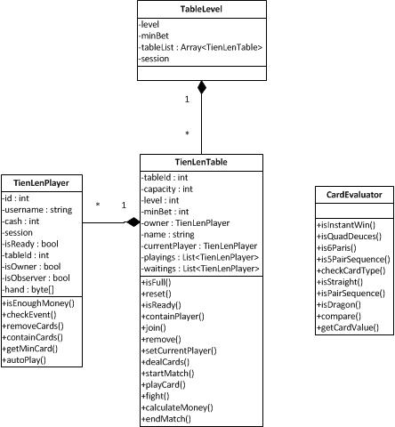
Figure 12. Game Class Diagram

TienLenPlayer
TienLenPlayer is the class representing user in the game. Class has the following attributes:
- id: The same as user’s id
- username: Name of user
- cash: Money in user’s account
- session: User’s session
- isReady: Specify user’s ready status
- tableId: Table’s id
- isOwner: Specify if user is table owner
- isObserver: Specify if user is an observer
- hand: Cards in player’s hand

Except for get and set method, TienLenPlayer has the following methods:
- isEnoughMoney(): Check if user has enough of money to play
- checkEvent(): Check if there is a live event and receive dropped item
- removeCards(): Remove played cards
- containCards(): Check if player’s hand has these cards
- getMinCard(): Get the card with minimum value
- autoPlay(): Automatically play cards on user’s turn if user doesn’t response

TienLenTable
TienLenTable is the class that controls the flow of the game and interacts with player objects. Class has following attributes:
- tableId: Table’s id
- capacity: Maximum player in the table
- level: Level of table
- minBet: Table’s minimum money
- owner: Table’s owner
- name: Table’s name
- currentPlayer: Player on the turn
- playings: Array of players playing game
- waitings: Array of players observing game

Except for set and get method, TienLenTable has the following methods:
- isFull(): Check if table is full
- reset(): Reset table’s attribute at the end of the match
- isReady(): Check if everyone is ready
- containPlayer(): Check if this player belongs to the table
- join(): Join user to the table
- remove(): Remove user from table
- setCurrentPlayer(): Choose player to start the match
- dealCards(): Deal cards to players
- startMatch(): Start match
- playCard(): User plays his card
- fight(): Process cards beating cards
- calculateMoney(): Calculate win/lose money
- endMatch(): Perform logic on end match

CardEvaluator
CardEvaluator is a utility class that provides method to evaluate strength of card group, detect its type and compare with another card group. Class provides the following methods:
- isInstantWin(): Check for an instant win
- isQuadDeuces(): Check if the hand contains four-of-a-kind of deuce.
- is6Pairs(): Check if the hand contains 6 pairs.
- Is5PairsSequence(): Check if the hand contains 5-pair sequence
- checkCardType(): Check type of card group
- isStraight(): Check if the hand is the straight
- isPairSequence(): Check if the hand has pair sequence
- isDragon(): Check if the hand is a Dragon’s head
- compare(): Compare the strength between two group of cards
- getCardValue(): Convert card index to strength indicator

Upon starting game, the server needs to count down the clock in each player’s turn. This is when Quartz job scheduler takes action by providing class and interface to handle countdown event.
- Scheduler: an interface and the main API for interacting with the scheduler.
- Job: an interface to be implemented by components that you wish to have executed by the scheduler.
- JobDetail: used to define instances of jobs.
- Trigger: a component that defines the schedule upon which a given Job will be executed.
- JobBuilder: used to define/build JobDetail instances, which defines instances of Jobs.
- TriggerBuilder: used to define/build Trigger instances.

A Scheduler’s life-cycle is bound by its creation, via a SchedulerFactory and a call to its shutdown() method. Once created the Scheduler can be used to add, remove and list Jobs and Triggers, and perform other scheduling-related operations (such as pausing a trigger). However, the Scheduler will not actually act on any triggers (execute jobs) until it has been started with the start() method. To set up for executing job, Schedule class performs initializing procedure by adding jobs into the scheduler. Jobs and Triggers are given identifying keys as they are register with the Quartz scheduler. The keys of Job and Triggers allow them to be placed into groups which can be useful for organizing jobs and triggers into categories.

private static void addJob(Class<? extends Job> jobClass, String identity, String cronExpression) throws ParseException, SchedulerException {
JobDetail job = newJob(jobClass).withIdentity(identity, "TLMN").build();

Trigger trigger = newTrigger().withIdentity(identity, "TLMN").withSchedule(CronScheduleBuilder.cronSchedule(cronExpression)).build();
scheduler.scheduleJob(job, trigger);
}

public static void makeSchedule() {
try {
addJob(GameJob.class, "GAME_MONITOR", GAME_MONITOR_CRON_EXPRESSION);
addJob(NumberOnlineJob.class, "NUMBER_ONLINE_MONITOR", NUMBERONLINE_MONITOR_CRON_EXPRESSION);
addJob(CommonMonitorJob.class, "COMMON_MONITOR", COMMON_MONITOR_CRON_EXPRESSION);

scheduler.start();
} catch (ParseException ex) {
log.error(ex.getMessage(), ex);
} catch (SchedulerException ex) {
ex.printStackTrace();
log.error(ex.getMessage(), ex);
}
}

In the above code, GameJob and CommonMonitorJob class are the implementation of Job interface which has only one simple method:
public interface Job {

public void execute(JobExecutionContext context)
throws JobExecutionException;
}

When the Job’s triggers fires, the execute() method is invoked by one of the scheduler’s worker thread. The JobExecutionContext object that is passed to this method provides the job instance with information about its runtime environment – a handle to the Scheduler that executed it, a handle to the Trigger that triggered the execution, the job’s JobDetail object and a few other items.

Each turn, a player has 30-second countdown to make decision either to play a card or pass his turn to another one. If he doesn’t play his turn on time or somehow server cannot receive the TurnPlay message, Quartz will pull the trigger and fire code inside execute() to call a doTimeout() method from TienLenTable object. This method then call autoplay() method of player who is currently on the turn. In case the player is on an open turn (play the first cards in a round), autoplay process will pick his weakest single card and counterfeit the TurnPlay message as if he actually play the card to maintain the flow of the game. Otherwise, player’s action will be understood as passing the turn and giving it up to the next player.

On a regular basis, client sends TurnPlay message to server packaging inside an array of cards of type byte to signal his play. Firstly, player’s decision is read by isGivenUp field whose true/false value indicates pass/play the turn. In playing case the cards are checked if they make a valid combination such as straight, pair or triple before they get passed into isContainCards() method to make sure these cards are in player’s hand. On an open turn, no more checking logic is performed and cards are removed from player’s hand, turn is passed to the next one, messages are broadcasted to the whole table. However, if the cards need to beat the previous played cards, a comparison is made to verify if the two combinations are of the same type and the current cards are stronger or they are in special beat situation. Two card groups of the same type are compared by their highest value card. A single card is evaluated by getCardValue() method.
public static int getCardValue(int b) {
int value = (b - 1) % 13;
switch (value) {
case 0:
return 11;
case 1:
return 12;
default:
return value - 2;
}
}

The idea of the method is to get the actual value of the card regardless of its suit by mod to 13 and move the value of the Ace and the Deuce to two highest values which are 11 and 12 respectively. After that game is checked for ending if player has released all of his cards. Money is calculated head-to-head by multiplying number of cards remaining on loser’s hand with minimum table money. Finally, user’s account gets updated into database, server broadcasts EndMatch message to whole table and game is reset for another match to start.

Reconnection
One problem that user usually encounters while playing the game is the network disconnection which is very disturbing if they cannot reconnect to the game to continue their action. Therefore, server provides a mechanism for the client to reconnect and recover its game state.
When disconnection happens, client only needs to send Reconnection message with user’s id, type of reconnection and possibly table’s id as the parameter. Firstly, server will find the dead session by id and remove it from SessionManager. Based on reconnection type, the processing is different.
- Type = 1 or reconnect to home only requires the session to be renewed and the message to be responded.
- Type = 2 or reconnect to game lobby: create new session and fake a join lobby message.
- Type = 3 or reconnect to table: create new session, look for TienLenPlayer object of reconnecting user in the table, attach it to user’s session and then return to client a message of full table information.

Result

CONCLUSION

“Tiến lên miền Nam” game system has fulfilled the most basic functions of an online game which are the authentication, creating game table, finding table, playing game, chatting, kicking, inviting friend and support feature like event and roulette. Because of running with one server, the game is capable of serving fewer than 1000 concurrent connections and approximately 200 playing tables. Game prevents cheating and hacking by frequently validating user’s request message and encoding important data. Given the above expectation, the game can attract the user to pay their cash to buy in-game money which will be marked as an essential function to be developed in near future. The game content could be further extended by adding more supporting feature such as item shop, player rank, head-to-head tournament and so on. One another improvement that can be considered to be implemented in a long term process is the expansion of the game to distributed server system so that the server capacity and geographic scope are bigger enough for a growing amount of users.
REFERENCES

Mẫu danh mục tài liệu tham khảo
* Bài báo đăng trên tạp chí khoa học : Tên tác giả, tên bài báo, tên tạp chí, volume, từ trang đến trang (nếu có), nhà xuất bản, năm xuất bản.
- Hovy E, Automated Discourse Generation Using Discourse Structure Relations, Artificial Intelligence, Elsevier Science Publishers, 63: 341-385, 1993.
* Sách : Tên tác giả, tên sách, volume (nếu có), lần tái bản (nếu có), nhà xuất bản, năm xuất bản.
- Peterson L. L. and Davie B. S. , Computer Networks: A Systems Approach, 2nd ed., Mogran-Kaufmann, 1999.
- Nguyễn Thúc Hải, Mạng máy tính và các hệ thống mở, Nhà xuất bản giáo dục, 1999.
* Tập san Báo cáo Hội nghị Khoa học : Tên tác giả, tên báo cáo, tên hội nghị, ngày (nếu có), địa điểm hội nghị, năm xuất bản.
- Poesio M. and Di Eugenio B., Discourse Structure and Anaphoric Accessibility, In Proc. of the ESSLLI Workshop on Information Structure, Discourse Structure and Discourse Semantics, Helsinki, 2001.
* Đồ án tốt nghiệp, Luận văn Thạc sĩ, Tiến sĩ : Tên tác giả, tên đồ án/luận văn, loại đồ án/luận văn, tên trường, địa điểm, năm xuất bản.
- Knott D., A Data-Driven Methodology for Motivating a Set of Coherence Relations, Ph.D. Thesis, University of Edinburgh, UK, 1996.
* Tài liệu tham khảo từ Internet : Tên tác giả (nếu có), tựa đề, cơ quan (nếu có), địa chỉ trang web, thời gian lần cuối truy cập trang web.
- Berners-Lee T., Hypertext Transfer Protocol (HTTP), CERN, URL:ftp:/info.cern.ch/pub/www/doc/http-spec.txt.Z, last visited May 2010.
- Princeton University, WordNet, http://www.cogsci.princeton.edu/~wn/index.shtml, last visited May 2010.

